Escapism – Concept art \ Story line

# Concept art

## First design

The player gets to play in the shoes of the Main Character, Zuha. I had allot of design changes for her, regarding her outfit, hair and pallete

First design: i didn’t really think the first design of Zuha through, if it colours used were complimentary, if i was satisfied with the hairstyle ex. The same would apply for the antagonist, Noor, too.

I also thought of drawing different designs of my characters when entering the “dream realm”, but i thought that woukd be too complicated and unnecessary for the player to experience

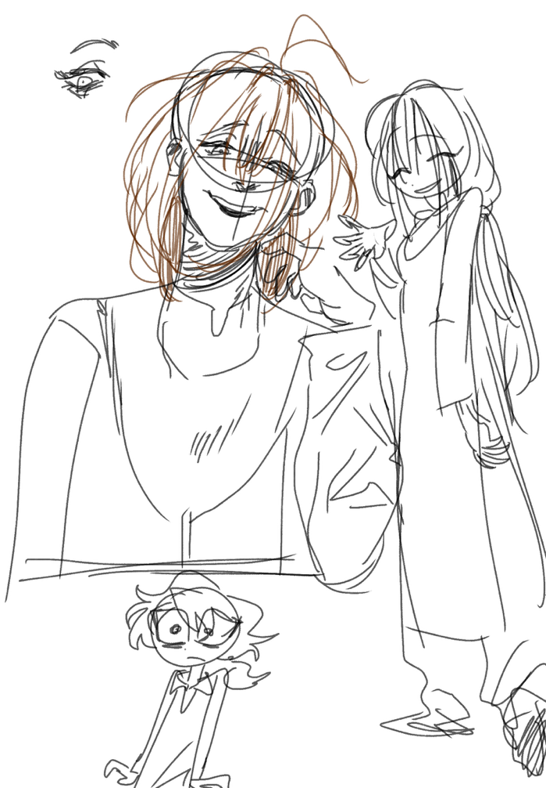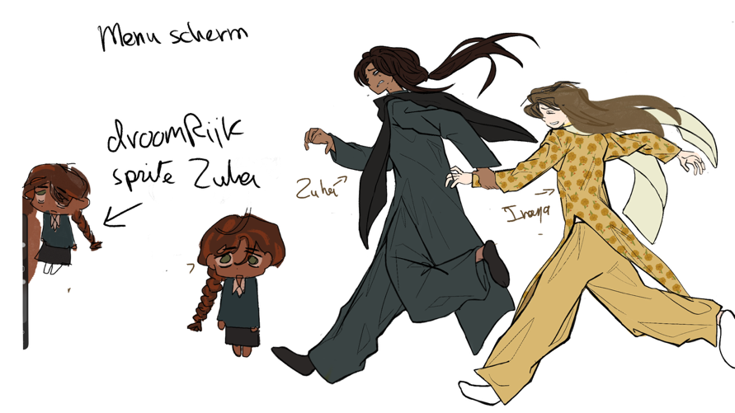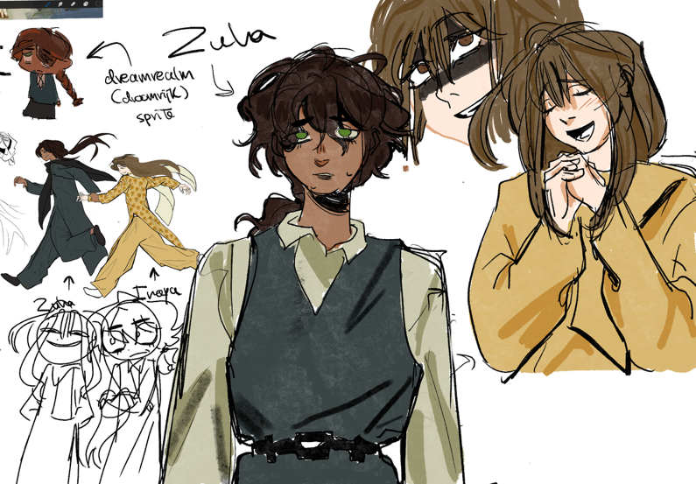

## Second design

I tried giving Zuha a different outfit that looked more like a school uniform (the first design was also school uniform, but it didnt come off as natural.

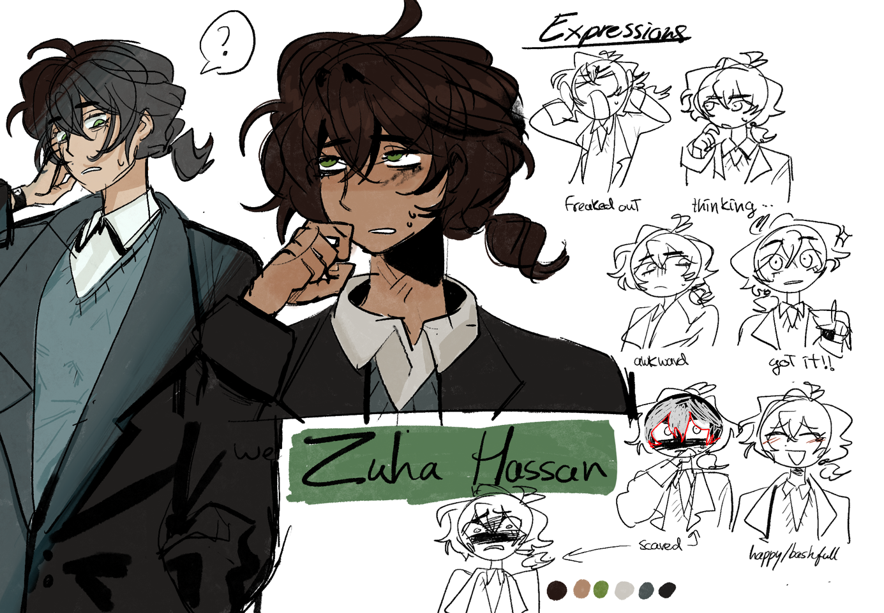I also decided on the sprites of Zuha and what emotions they would convey

## Final design

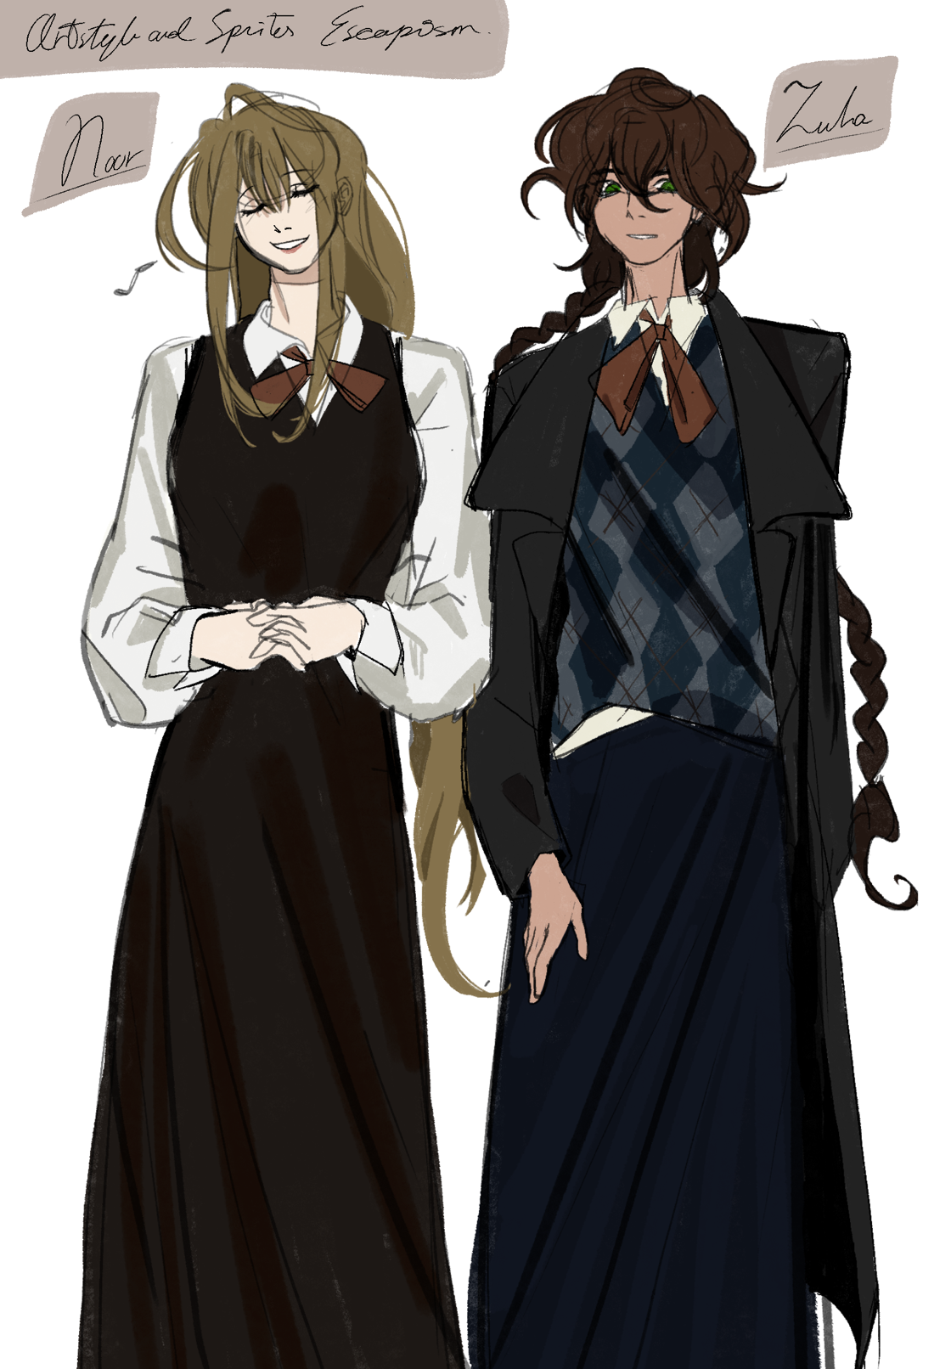I finally figured out the design that was most appealing to me. I gave Zuha a big change in her hairstyle and school uniform, really considering the pallete this time.

Noor also got a wardrobe change, and slight improvement in her pallete.

## 

## 

## 

## Game mechanic art concept

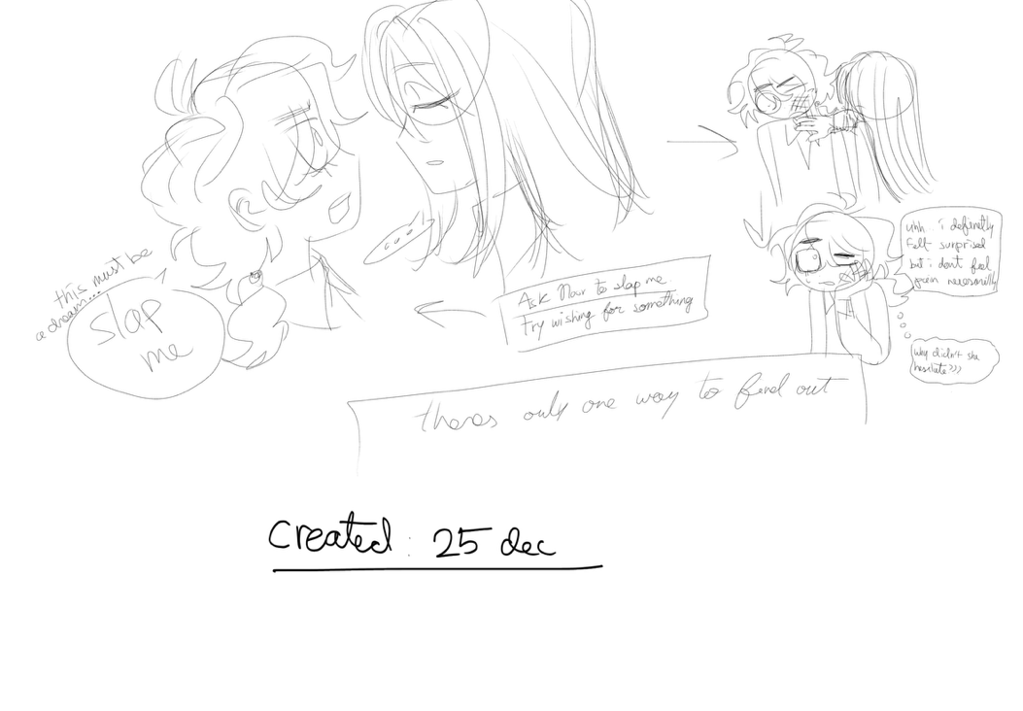For this specific scene in the dream realm, Zuha has to choose what method they could try out to check if they were in a dream. One of them was to ask Noor to slap her. I tried to present this idea visually:

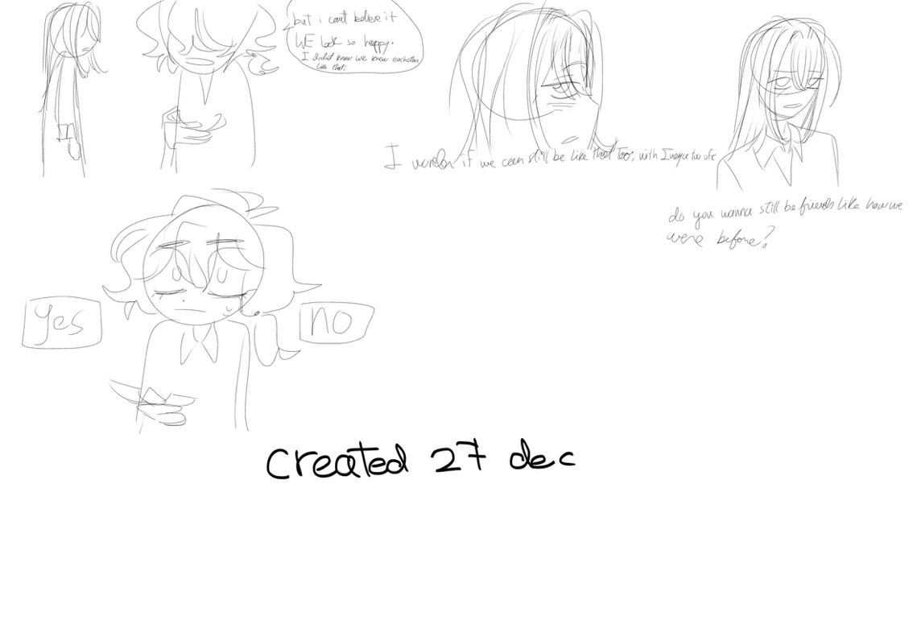For another, rather touching and important scene (still in the dream realm), Zuha gets the option to still be friends with Noor, like how they were before, i again sketched this idea out.

T

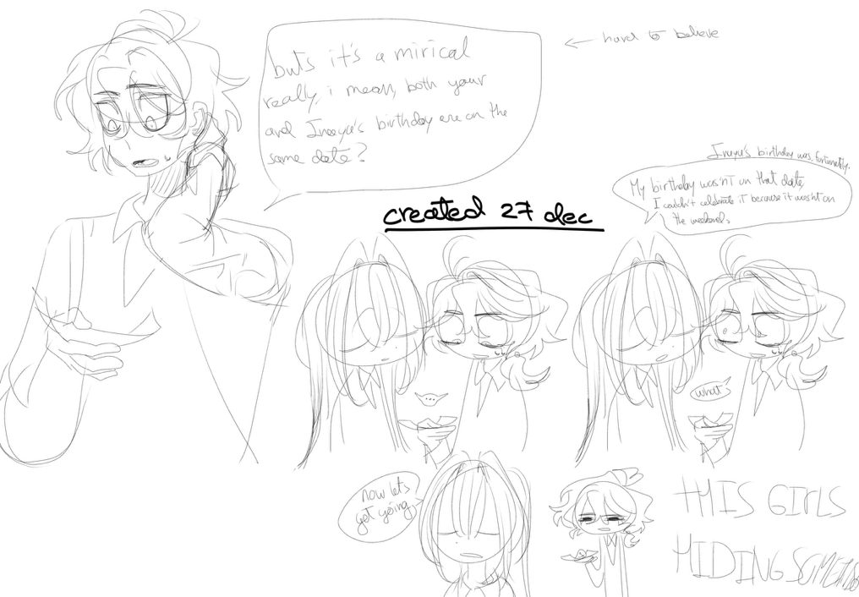The scene in my game where Zuha discovers her childhood friends in a picture, she sees Noor and Inaya both celebrating their birthday on the same day, Zuha asks how this is possible, and Noor shrugs it off. I, again, drew this idea to clarify the dialouge and expressions.

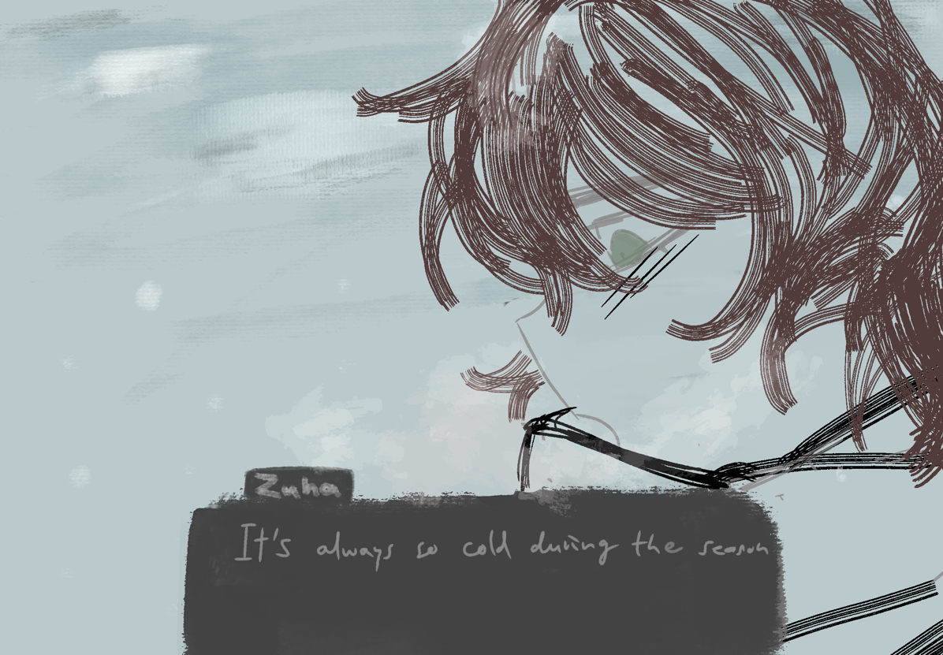This is one of the first CG art sketches that i made of Zuha for my game:

## Full branch story concept

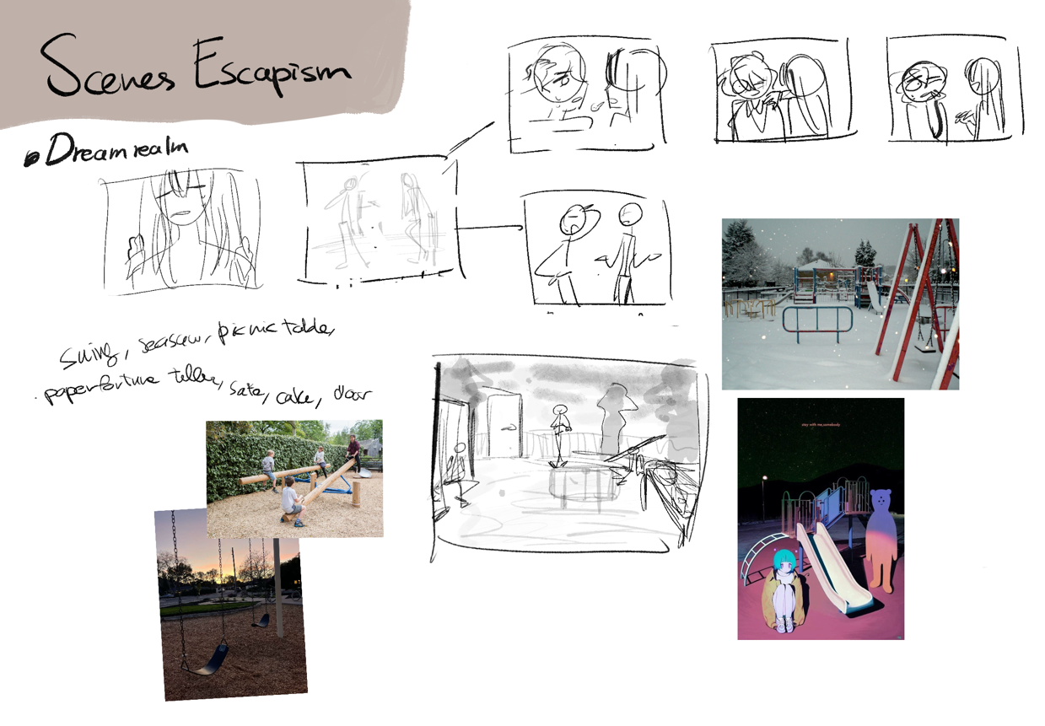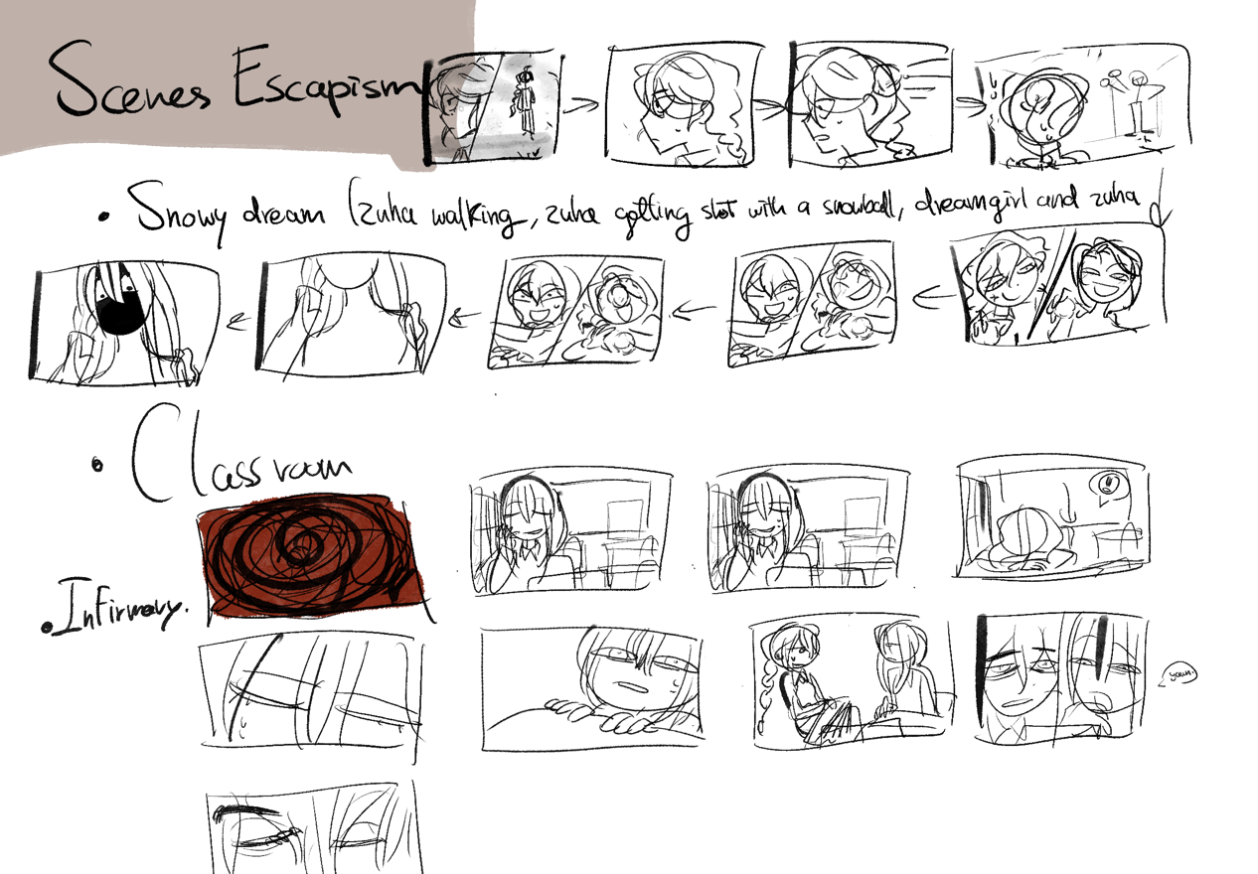Here i drew every scene that i needed to draw for my game to clarify and not overdue the assets, CG art and to understand the flow of my game. I went along with this flow, and removed some unnecessary scenes



# Concept story

I spent 9 days figuring out a different plot to my story. I changed almost everything if comparing to my previous concept story for my game, i needed to change the puzzles, the start, middle and end of my game for my new idea.

My initial concept for the story was for the mc to think that her bestfriend (Inaya) didn’t die and the person she was hanging out with all this time was Inaya, but it was actually the best friend’s twin sister (Noor). It was a mystery type game where the player had to solve this mystery. But i realised that i wanted a game to give the player an important message after playing my game, Escapism;

To stay strong and to overcome something tragic and not run away from it.

(Hence the name escapism, to escape to a fake reality)

I really wanted to show this message through storytelling, but for that to happen, i had to scrap out 90% of my whole story, the other 10% percent being to still include the whole “stuck in a dream with another classmate” part.

I had to think hard and come up with something new, i thought it would only take a day (who wouldn’t), but it cost me my entire vacation. I didn’t know how the game start, progress and end, i only knew the dream part.

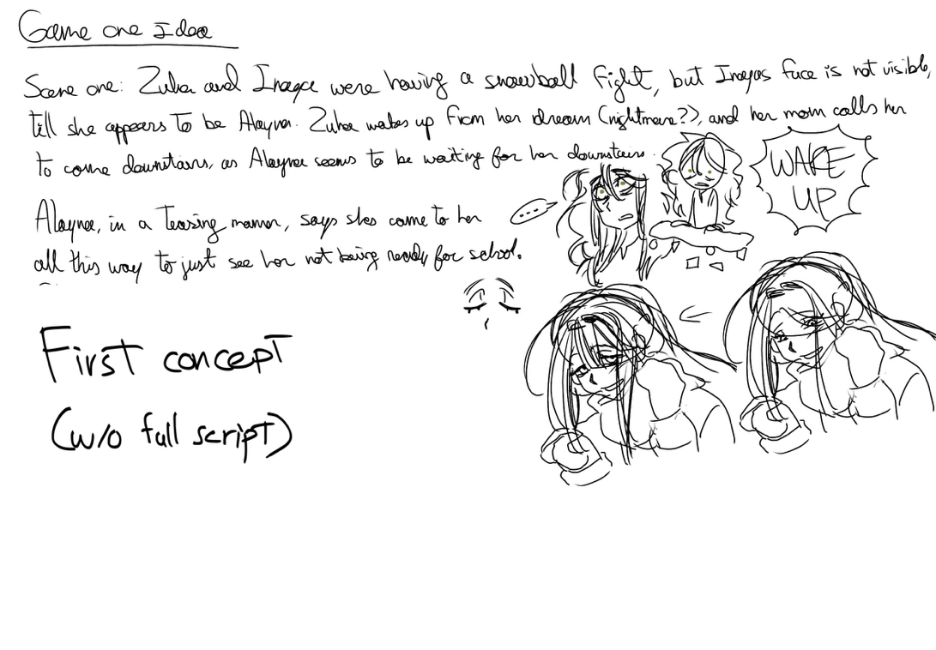I sketched every scene of the intro of my game, how it would start of and progress to the main gameplay scene (dreamrealm), but i would like to show my original (old) concept first:

